Introduction to Iterators

Imagine you had a grocery list and you wanted to know what each item on the list was. You’d have to scan through each row and check for the item. This common task is similar to what we have to do when we want to iterate over, or loop through, an array. One tool at our disposal is the for loop. However, we also have access to built-in array methods which make looping easier.

The built-in JavaScript array methods that help us iterate are called *iteration methods*, at times referred to as *iterators*. Iterators are methods called on arrays to manipulate elements and return values.

In this lesson, you will learn the syntax for these methods, their return values, how to use the documentation to understand them, and how to choose the right iterator method for a given task.

The .forEach() Method

The first iteration method that we’re going to learn is .forEach(). Aptly named, .forEach() will execute the same code for each element of an array.  
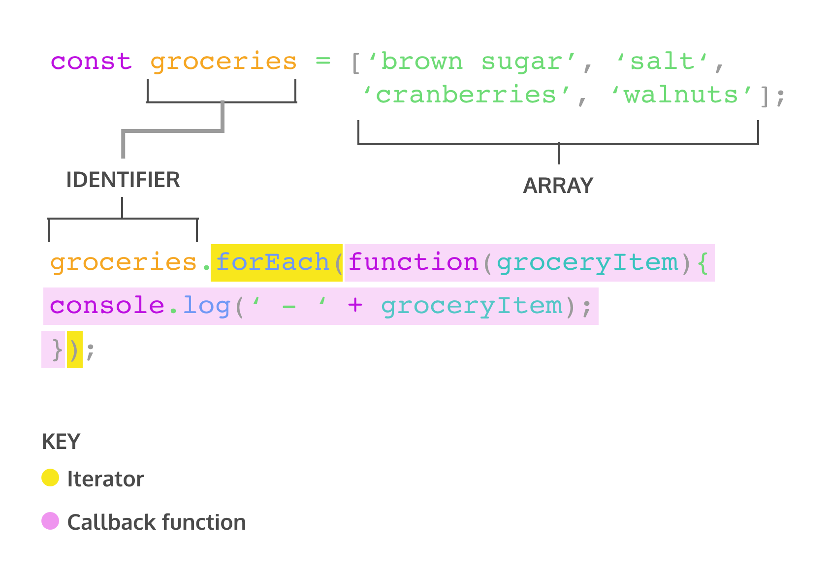

The code above will log a nicely formatted list of the groceries to the console. Let’s explore the syntax of invoking .forEach().

* groceries.forEach() calls the forEach method on the groceries array.
* .forEach() takes an argument of callback function. Remember, a callback function is a function passed as an argument into another function.
* .forEach() loops through the array and executes the callback function for each element. During each execution, the current element is passed as an argument to the callback function.
* The return value for .forEach() will always be undefined.

Another way to pass a callback for .forEach() is to use arrow function syntax.

groceries.forEach(groceryItem => console.log(groceryItem));

We can also define a function beforehand to be used as the callback function.

function printGrocery(element){  
  console.log(element);  
}  
   
groceries.forEach(printGrocery);

The above example uses a function declaration but you can also use a function expression or arrow function as well.

All three code snippets do the same thing. In each array iteration method, we can use any of the three examples to supply a callback function as an argument to the iterator. It’s good to be aware of the different ways to pass in callback functions as arguments in iterators because developers have different stylistic preferences. Nonetheless, due to the strong adoption of ES6, we will be using arrow function syntax in the later exercises.

### Instructions

**1.**

Iterate over the fruits array to log I want to eat a plus the name of each fruit to the console. For example, I want to eat a mango.

You may use any form of callback you prefer.

The .map() Method

The second iterator we’re going to cover is .map(). When .map() is called on an array, it takes an argument of a callback function and returns a new array! Take a look at an example of calling .map():

const numbers = [1, 2, 3, 4, 5];   
   
const bigNumbers = numbers.map(number => {  
  return number * 10;  
});

.map() works in a similar manner to .forEach()— the major difference is that .map() returns a new array.

In the example above:

* numbers is an array of numbers.
* bigNumbers will store the return value of calling .map() on numbers.
* numbers.map will iterate through each element in the numbers array and pass the element into the callback function.
* return number * 10 is the code we wish to execute upon each element in the array. This will save each value from the numbers array, multiplied by 10, to a new array.

If we take a look at numbers and bigNumbers:

console.log(numbers); // Output: [1, 2, 3, 4, 5]  
console.log(bigNumbers); // Output: [10, 20, 30, 40, 50]

Notice that the elements in numbers were not altered and bigNumbers is a new array.

**Instructions**

**1.**

Add your code under the animals array and before the line console.log(secretMessage.join(''));

Use .map() to create a new array that contains the first character of each string in the animals array. Save the new array to a const variable named secretMessage.

Checkpoint 2 Passed

Stuck? Get a hint

**2.**

Use .map() to divide all the numbers in bigNumbers by 100. Save the returned values to a variable declared with const called smallNumbers.

The .filter() Method

Another useful iterator method is .filter(). Like .map(), .filter() returns a new array. However, .filter() returns an array of elements after filtering out certain elements from the original array. **The callback function for the .filter() method should return true or false depending on the element that is passed to it. The elements that cause the callback function to return true are added to the new array**. Take a look at the following example:

const words = ['chair', 'music', 'pillow', 'brick', 'pen', 'door'];   
   
const shortWords = words.filter(word => {  
  return word.length < 6;  
});

* words is an array that contains string elements.
* const shortWords = declares a new variable that will store the returned array from invoking .filter().
* The callback function is an arrow function has a single parameter, word. Each element in the words array will be passed to this function as an argument.
* word.length < 6; is the condition in the callback function. Any word from the words array that has fewer than 6 characters will be added to the shortWords array.

Let’s also check the values of words and shortWords:

console.log(words); // Output: ['chair', 'music', 'pillow', 'brick', 'pen', 'door'];   
console.log(shortWords); // Output: ['chair', 'music', 'brick', 'pen', 'door']

Observe how words was not mutated, i.e. changed, and shortWords is a new array.

**Instructions**

**1.**

Call the .filter() method on randomNumbers to return values that are less than 250. Save them to a new array called smallNumbers, declared with const.

Stuck? Get a hint

**2.**

Now let’s work with an array of strings. Invoke .filter() on the favoriteWords array to return elements that have more than 7 characters. Save the returned array to a const variable named longFavoriteWords.

The .findIndex() Method

We sometimes want to find the location of an element in an array. That’s where the .findIndex() method comes in! Calling .findIndex() on an array will return the index of the first element that evaluates to true in the callback function.

const jumbledNums = [123, 25, 78, 5, 9];   
   
const lessThanTen = jumbledNums.findIndex(num => {  
  return num < 10;  
});

* jumbledNums is an array that contains elements that are numbers.
* const lessThanTen = declares a new variable that stores the returned index number from invoking .findIndex().
* The callback function is an arrow function has a single parameter, num. Each element in the jumbledNums array will be passed to this function as an argument.
* num < 10; is the condition that elements are checked against. .findIndex() will return the index of the first element which evaluates to true for that condition.

Let’s take a look at what lessThanTen evaluates to:

console.log(lessThanTen); // Output: 3

If we check what element has index of 3:

console.log(jumbledNums[3]); // Output: 5

Great, the element in index 3 is the number 5. This makes sense since 5 is the first element that is less than 10.

If there isn’t a single element in the array that satisfies the condition in the callback, then .findIndex() will return -1.

const greaterThan1000 = jumbledNums.findIndex(num => {  
  return num > 1000;  
});  
   
console.log(greaterThan1000); // Output: -1

**Instructions**

**1.**

Invoke .findIndex() on the animals array to find the index of the element that has the value 'elephant' and save the returned value to a const variable named foundAnimal.

Stuck? Get a hint

**2.**

Let’s see if we can find the index of the first animal that starts with the letter 's'.

Call .findIndex() on the animals array return the index of the first element that starts with 's'. Assign the returned value to a const variable named startsWithS.

Stuck? Get a hint

The .reduce() Method

Another widely used iteration method is .reduce(). The .reduce() method returns a single value after iterating through the elements of an array, thereby *reducing* the array. Take a look at the example below:

const numbers = [1, 2, 4, 10];  
   
const summedNums = numbers.reduce((accumulator, currentValue) => {  
  return accumulator + currentValue  
})  
   
console.log(summedNums) // Output: 17

Here are the values of accumulator and currentValue as we iterate through the numbers array:

| **Iteration** | **accumulator** | **currentValue** | **return value** |
| --- | --- | --- | --- |
| First | 1 | 2 | 3 |
| Second | 3 | 4 | 7 |
| Third | 7 | 10 | 17 |

Now let’s go over the use of .reduce() from the example above:

* numbers is an array that contains numbers.
* summedNums is a variable that stores the returned value of invoking .reduce() on numbers.
* numbers.reduce() calls the .reduce() method on the numbers array and takes in a callback function as argument.
* The callback function has two parameters, accumulator and currentValue. The value of accumulator starts off as the value of the first element in the array and the currentValue starts as the second element. To see the value of accumulator and currentValue change, review the chart above.
* As .reduce() iterates through the array, the return value of the callback function becomes the accumulator value for the next iteration, currentValue takes on the value of the current element in the looping process.

The .reduce() method can also take an optional second parameter to set an initial value for accumulator (remember, the first argument is the callback function!). For instance:

const numbers = [1, 2, 4, 10];  
   
const summedNums = numbers.reduce((accumulator, currentValue) => {  
  return accumulator + currentValue  
}, 100)  // <- Second argument for .reduce()  
   
console.log(summedNums); // Output: 117

Here’s an updated chart that accounts for the second argument of 100:

| **Iteration #** | **accumulator** | **currentValue** | **return value** |
| --- | --- | --- | --- |
| First | 100 | 1 | 101 |
| Second | 101 | 2 | 103 |
| Third | 103 | 4 | 107 |
| Fourth | 107 | 10 | 117 |

**Instructions**

**1.**

Let’s practice calling .reduce() and using console.log() to check the values as .reduce() iterates through the array.

In **main.js**, there is an array of numbers, newNumbers.

To start, declare a new variable named newSum using the const keyword. Assign to newSum the value of calling .reduce() on newNumbers. You don’t need to provide any arguments to .reduce() yet.

You’ll also see a TypeError: undefined is not a function but we’ll fix that after we add our callback function in the next step!

Checkpoint 2 Passed

Stuck? Get a hint

**2.**

Provide .reduce with an argument of a callback function. The callback function has two parameters. The first parameter is accumulator and the second parameter is currentValue. Use either a function expression or an arrow function.

Checkpoint 3 Passed

Stuck? Get a hint

**3.**

To check the value being used as we iterate through the array, add three statements to the function body of the callback:

* console.log('The value of accumulator: ', accumulator);
* console.log('The value of currentValue: ', currentValue);
* a return statement that adds accumulator to currentValue.

Checkpoint 4 Passed

Stuck? Get a hint

**4.**

Log the value of newSum to the console to see the return value of calling .reduce() on newNumbers.

Checkpoint 5 Passed

**5.**

While we have this code set up, let’s also check what happens if you add a second argument to .reduce(). The second argument acts as an initial value for the accumulator.

Add a second argument of 10 to .reduce().

# Array.prototype.every()

The **every()** method tests whether all elements in the array pass the test implemented by the provided function. It returns a Boolean value.

const isBelowThreshold = (currentValue) => currentValue < 40;

const array1 = [1, 30, 39, 29, 10, 13];

console.log(array1.every(isBelowThreshold));

// expected output: true

# Array.prototype.some()

The **some()** method tests whether at least one element in the array passes the test implemented by the provided function. It returns true if, in the array, it finds an element for which the provided function returns true; otherwise it returns false. It doesn't modify the array.

const array = [1, 2, 3, 4, 5];

// checks whether an element is even

const even = (element) => element % 2 === 0;

console.log(array.some(even));

// expected output: true

# Array.prototype.find()

The find() method returns the value of the first element in the provided array that satisfies the provided testing function. If no values satisfy the testing function, [undefined](https://developer.mozilla.org/en-US/docs/Web/JavaScript/Reference/Global_Objects/undefined) is returned.

const array1 = [5, 12, 8, 130, 44];

const found = array1.find(element => element > 10);

console.log(found);

// expected output: 12